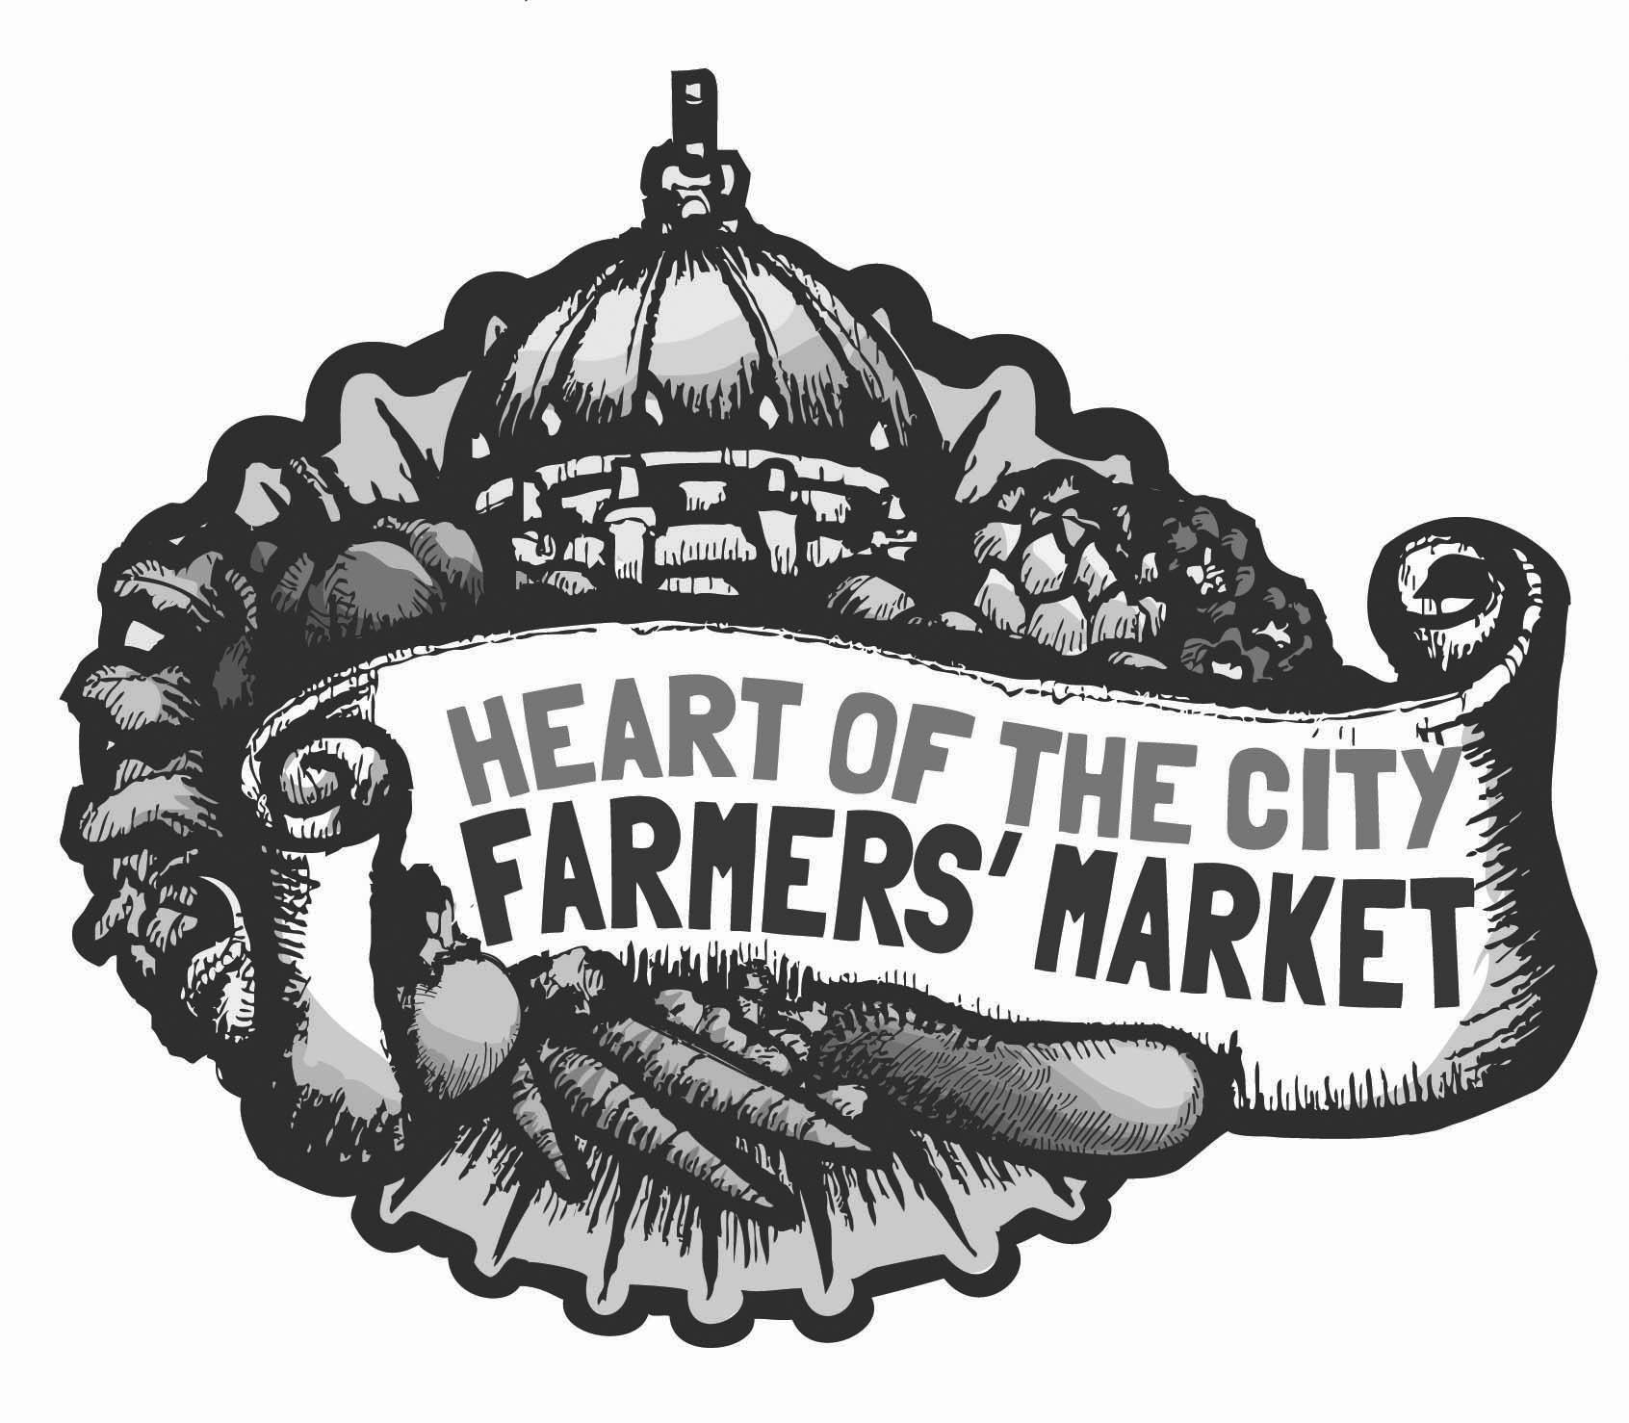
Heart of the City Farmers’ Market
STALL APPLICATION

Farm/Business Name: | □ Day Phone:  □ Evening Phone:  □ Cell Phone:  Please check the box of the best phone number to reach you.
Owner Name:

Mailing Address: | Email Address:
 | Website:
Type of products you will sell: | Will you be selling any processed or hot foods?  □ No  □ Yes If so, attach a copy of your licenses/health permit(s).
Producer Certification Number (Required for certified producers only):  Expiration Date:  Attach a copy of your Certified Producer Certificate. | Will you be selling any organic foods?  □ No  □ Yes If so, attach copies of your State and certification organization certificates.
I request that Heart of the City Farmers’ Market allow my farm/business to sell at the market when a stall space becomes available. I understand this does not guarantee me a reserved stall space on an ongoing basis, but that I will have priority status on the waiting list to be granted a stall reservation in the future as space becomes available. I understand my eligibility depends on the similarity of the products I sell compared to products already available at the market and priority will be given to vendors who provide unique products.

I understand I must meet all conditions below before selling (please check to confirm if you have met them.)
□ I have read and agree to operate according to the Heart of the City Farmers’ Market Rules & Regulations.
□ I have read, understand, and signed the Participation Agreement.
□ I have read, understand, and signed the Heart of the City Farmers’ Market Anti-Discrimination Policy.
□ I am including proof of current commercial liability insurance and proof of current auto insurance. I understand that prior to selling, I must list the market as co-insured on my commercial liability policy.
□ If I am a farmer, I am including a copy of my Certified Producer Certificate. If I will sell organic food, I have also attached copies of the required State and certification organization certificates. If you are not a certified producer, leave this box unchecked.
□ If I will be selling processed or prepared foods, I am aware that I must work with market management to obtain all required licenses and health permits. I hereby confirm I can meet all requirements to sell at a farmers’ market in San Francisco and understand it is my responsibility to know and meet all requirements for my specific business. I recognize that Heart of the City Farmers Market does not provide training for new businesses in this area. If you do not sell processed or hot foods, leave this box unchecked.
______________________________________________________________________________________
Authorized Signature Date

Heart of the City Farmers’ Market
ADDITIONAL APPLICATION QUESTIONS

- Farm or Business Location: _____________________________
  - If you are a farmer, please circle one: Leased/Owned If leased, please attach a copy of your lease.

- Describe the history, character, and philosophy of your farm or business:

- To help us better understand your interest, answer the questions below. Please understand this does not guarantee availability.
  - What days do you hope to attend the market? Circle one or both: Wednesday / Sunday
  - What size stall are you requesting? Note that you must provide overhead covering for the entire selling area. If you provide hot or processed food, you must also cover your storage area.
Circle one: Half Stall (5’x10’) / One Stall (10’x10’) / Two Stalls (10’x20’) / Larger
Please explain:

  - Do you plan to attend during every month of the year? Circle one: Yes / No If no, please describe your ideal selling situation below.

- Please list every product you plan to sell at the market and the approximately timeline of availability for each product. If you will be selling prepared food, please also list your prices. Use the back of this sheet if necessary.

Heart of City Farmers’ Market
PARTICIPATION AGREEMENT

I hereby acknowledge receipt of and agree to abide by the Heart of the City Farmers’ Market Rules and Regulations. If I am accepted as a vendor at the market, my stall fee will be $55 per 10’x10’ selling area. There is an additional parking fee of $20 for parking in farmers market designated areas.

I hereby agree and understand that the participation of my farm/business will be based upon the following factors: reliable attendance, cooperation with the Market Manager, quality of products sold, submission of completed load lists, submission of current proof of insurance, submission and daily posting of current certification, licenses, or permits, adherence to market rules and regulations, and adherence to California Direct Marketing Regulations.

I hereby agree, as a vendor at Heart of the City Farmers’ Market, to indemnify, defend, and hold Heart of the City Farmers Market (“HOCFM”) and its Board of Directors, officers, members, employees, and agents harmless from and against any and all liability, claims, damages, suits, actions, causes of actions, judgments, penalties, fines, costs and expenses (including attorney's fees) arising from my or my farm/business’s participation in HOCFM. Said indemnification and defense shall include, but not be limited to, any cause related to bodily injury, personal injury, property damage, defamation, or violation of any Federal, State or municipal law or ordinance (including but not limited to civil rights and health and safety related laws or ordinances) or any other cause naming HOCFM or any of its Board of Directors, officers, members, employees, or agents, or in connection with the activities of HOCFM, its Board of Directors, officers, members, employees, or agents, or on account of the performance or character of the work.

All HOCFM Vendors shall maintain commercial liability insurance policies expressly naming HOCFM and its Board of Directors, officers, members, employees, and agents as additional insureds, with policy limits of at least $1 million. All HOCFM vendors shall maintain current auto insurance policies. Proof of current auto and commercial liability insurance (i.e. proof that premium payments have been made) must be furnished on an annual basis. This requirement to maintain insurance is in addition to, and not a substitute for, producer’s explicit agreement to hold HOCFM harmless, as set forth above.

I hereby declare that I have the authority to sign this acknowledgment/agreement as the representative of the participating farm/business. By signing this acknowledgment/agreement, I acknowledge that a representative of HOCFM is hereby given permission to visit the location(s) where my products are produced and/or stored to verify compliance with the Heart of the City Farmers’ Market Rules and Regulations and the State of California’s regulations.

____________________________________________________________
Signature Date

__________________________________________
Print Name

__________________________________________
Farm/Business Name
Heart of the City Farmers’ Market
ANTI-DISCRIMINATION POLICY

Heart of the City Farmers Market (“HOCFM”) prohibits discrimination against any applicant for employment, employee, vendor, producer, patron, customer, or member of the public, based on actual or perceived race, religion, creed, color, national origin or ancestry, place of birth, sex (including pregnancy, childbirth, or related medical conditions), disability, medical condition, marital status, age, sexual orientation, gender identity, AIDS or HIV status, height, weight, veteran status, active or reserve military status, parental status, or any other basis protected by federal, state, or local law or ordinance or regulation. All such discrimination is unlawful.

Vendors shall not engage in any unlawful discrimination, and, in particular, shall not discriminate against any applicant for employment, employee, producer, vendor, patron, customer, or member of the public, based on actual or perceived race, religion, creed, color, national origin or ancestry, place of birth, sex (including pregnancy, childbirth or related medical conditions), disability, medical condition, marital status, age, sexual orientation, gender identity, AIDS or HIV status, height, weight, veteran status, active or reserve military status, parental status, or any other basis protected by federal, state, or local law or ordinance or regulation.

Unlawful discrimination includes failure or refusal to hire, discharge, or treatment of an applicant for employment or an employee less favorably than others with respect to compensation, promotions, or other terms, conditions or privileges of employment because of any of the factors listed above. Harassment that is based on any of the factors listed above and is sufficiently severe or pervasive to alter the conditions of employment may constitute unlawful discrimination. Unlawful discrimination also includes denial, directly or indirectly, any person, including customers, patrons, and members of the public, the full and equal enjoyment of the goods, services, facilities, privileges, advantages, and accommodations of HOCFM or any stall or producer, or to boycott, blacklist, surcharge, or refuse to buy from, contract with, sell to, or trade with any person because of any of the factors listed above.

Prohibited unlawful discrimination may also include the following behavior, depending on the circumstances:
- Verbal conduct such as epithets, slurs, derogatory jokes or comments, or unwanted sexual advances, invitations, or comments because of or relating to any of the factors listed above;
- Visual conduct such as derogatory and/or sexually oriented posters, photography, cartoons, drawings, or gestures because of or relating to any of the factors listed above.
- Physical conduct such as assault, unwanted touching, blocking normal movement because of or relating to any of the factors listed above.
- Threats and demands to submit to sexual requests as conditions of continued employment, or to avoid some other loss, and offers of employment benefits in return for sexual favors; and
- Retaliation for having reported or threatened to report discrimination or harassment.

By signing below, I hereby acknowledge receipt of and agree to abide by Heart of the City Farmers’ Market’s Anti-Discrimination Policy.

____________________________________________________________
Signature Date

__________________________________________
Print Name

